60.0 Fundamentals of recrystallization in Binary Nb-alloys
Will Waliser (Mines)
Faculty: Amy Clarke and Kester Clarke (Mines)
Industrial Mentor: Matthew Carl and Noah Philips (ATI)

This project initiated in Fall 2021 and is supported by CANFSA. The research performed during this project will serve as the basis for a PhD program for Will Waliser.

Project Overview and Industrial Relevance
Niobium is a relatively lightweight refractory metal with a wide variety of applications, including the manufacturing of refractory alloys, refractory multi-principal element alloys (RMPEA), and superconducting components. Niobium based superconductors such as Nb₃Sn or NbTi are type II superconductors favored in industry for their high magnetic flux densities, commercial reliability, and availability [60.1-60.2]. In particular, Nb₃Sn has proven itself to be a powerful superconductor, with new strides in alloy development pushing its capabilities even further. Recent studies have shown additions of Hafnium to Nb alloys used in making Nb₃Sn wires improved performance while in the superconducting state [60.1-60.2]. These Hf additions to Nb result in the suppression of grain growth and recrystallization behavior by raising the effective recrystallization (Rx) temperature, resulting in the stabilization of grain growth kinetics during annealing and Nb₃Sn formation temperatures. This leads to the stabilization of heavily worked structures at the Nb₃Sn formation temperatures, allowing for an increase in grain boundary diffusion paths for Sn into the base Nb alloy [60.3]. As such, the final microstructure in the superconducting phase will have a finer grain structure, causing an increase in flux pinning and ultimately improving its performance as a superconductor.

Given these recent findings and the reputed capabilities of Nb₃Sn superconductors, it has become the superconductor of choice for the development of future particle accelerators, as well as a variety of other industrial applications in high energy physics and medicine [60.2]. As such, manufacturers will need to be capable of meeting the increase in demand in an economically feasible way. Unfortunately, Hf is a constrained resource and could become a major limiting factor for manufacturers in the future. Therefore, cost effective alternative alloying elements capable of producing similar results without detrimental formability effects will need to be identified. To do this, a series of binary Nb alloys will be created with elements including Ti, Zr, Hf, V, Ta, Mo, W, and Re. These alloys will be subjected to varying degrees of deformation (>60%), with hardness measurements being taken to observe work hardening behavior, before being subjected to various heat treatments in the Gleeble® thermal-mechanical simulator. Scanning electron microscopy (SEM) and electron backscattered diffraction (EBSD) will be used to observe the resulting microstructural evolution and will allow for a fundamental understanding of how these alloying elements affect the recrystallization parameters of Nb. In doing so, this project aims to provide useful information for future developments of Nb-based superconductors and RMPEA applications.

Previous Work

Literature Review
Work began with a literature review spanning the topics of superconductivity, phase stabilities, and recrystallization and mechanical behavior of refractory alloys. Doing so has helped to provide a state-of-the-art understanding of the key issues and variables relevant to this study, as well as current research capabilities, terminology, and techniques. Furthermore, it has given a basis for selecting alloying elements and compositions of interest to test. Group IV alloying elements (Ti, Zr, Hf) have been shown to provide strengthening effects through solid solution strengthening (SSS) and a proclivity to form nonmetallic compounds with impurities present in the Nb, which can cause dislocation pinning and potentially grain boundary pinning as well [60.4-60.5]. This preference for forming nonmetallic compounds stems from the higher thermodynamic activity of these elements in comparison to Nb, and can also be seen when alloying with vanadium [60.4][60.8]. Furthermore, refractory elements of Mo, Ta, W, and Re all exhibit SSS when alloyed with Nb, as well as have significantly higher melting temperatures. As such there is reason to believe that several of the elements selected for testing may be effective as a replacement for Hf.

CALPHAD Simulations and Binary Manufacturing
Binary phase diagrams were generated in ThermoCalc™ to observe phase stabilities and solubility for a total of 18 different alloying elements. Elements that formed solid solutions with Nb at low concentrations were chosen to be used for the initial round of binary tests, with compositions selected based on further guidelines used for various commercial Nb based alloys [60.8]. Initial binary samples were manufactured via vacuum arc melting with alloying element concentrations of 2 wt.%, with the exception of Re which will be ~1wt.% for cost related reasons. Nearly all materials for manufacturing alloys were supplied by ATI Materials. These 2 wt.% binary buttons along with some stock C-103 were machined to provide a number of compression samples for testing in the Gleeble, to begin documenting the work hardening behavior and flow stress values. [60.9, 60.11-13].

A draft heat treatment plan has been proposed, in which samples deformed by warm rolling between 400 to 725 ºC will be sectioned and subject to two different heat treatments. As outlined in Table 60.1 below, the primary heat treatment temperature was based around 0.4T_{mNb} (1,263.2 K) for an hour, while secondary heat treatment temperature is performed at a slightly higher temperature, dependent on the alloying material [60.3][60.6]. ThermoCalc™ simulations were used to predict the theoretical melting temperatures of these binaries, from which the secondary temperatures were derived (1050 ºC, 1075 ºC, and 1100 ºC). Rolling parameters such as temperature and incremental degree of deformation were to be informed by gathering data from Gleeble compression testing.

Recent Progress

60.3.1 Gleeble compression tests
Wrought C-103 was machined into testing cylinders (12 mm length x 8 mm diameter) for compression testing in the Gleeble at temperatures of 400 ºC, 550 ºC, 725 ºC and strain rates of 10, 1, and 10⁻³ s⁻¹, using a stacking of grafoil and nickel paste lubricants for better control of temperature and friction reduction. This procedure led to the procurement of the data of the mechanical data seen in Figure 60.1, demonstrating the typically dependance of yield strength dependance on temperature and strain rate in BCC metals. This data was used to create hot processing maps, seen in Figure 60.2, which shows regions in temperature and strain rate space which are most efficient at imparting deformation energy towards microstructural change. Despite these tests being done under flowing argon, oxidation was observed on samples tested at quasistatic rates, with some minor oxidation see at higher temperature and strain rate conditions. No cracking was observed in any tested wrought C-103 material. The acceptable temperature range for favorable ductile deformation of these alloys is wider than initially expected, however due to the inherent sensitivity of the alloys to oxidation, and corresponding extreme degradation effects it can have on mechanical properties, it appears deformation at lower temperatures is more preferable, despite the increase in yield strength as minimization of oxidation is more important.

As-cast 2 wt.% binaries and commercially pure (CP) Nb buttons were machined into testing cylinders (9 mm length x 6 mm diameter) for continued compression testing in the Gleeble at room temperature and strain rates of 10 and 1 s⁻¹. For these tests, only dry graphite lubricant was used on the compression platens. From these tests it appeared that rolling to at least 60% reduction at room temperature could be done safely for most of the alloys, with exception to Zr, W, and Ta. This likely due to impurities in composition of the alloys, and not necessarily due to the alloying elements themselves being detrimental on mechanical properties. The data for these compositions can be seen in Table 60.2 in which W, Zr, and Ta alloys all have some degree of higher than intended interstitial content, denoted in yellow. Additionally, the residual as-cast microstructure from the buttons being machined into cylinders, could also affect the observed mechanical behavior. Further investigation will be conducted to understand which alloys should be eliminated from further testing, and which alloys should be re-made or require additional processing prior to rolling or compression.

C-103 EBSD and LOM imaging
In addition to compression tests, a number of C-103 samples have been analyzed and imaged via EBSD using the FEI Helios and TESCAN S8252G electron microscopes at Mines. The wrought C-103 samples used to generate the data in Figures 60.1-2 can be seen in Figure 60.3, where there appears to have been very little difference across resulting microstructures in the testing matrix, which is reflected in the mechanical data. Additionally, samples of C-103 tested under high temperature Kolsky bar conditions were obtained from another student’s previous work at Mines [60.14], where the resulting mechanical behavior obtained from these tests can be seen in Figure 60.4. These samples underwent similar metallographic preparation for LOM and EBSD imaging, which can be seen in Figure 60.5 showing the results of the highest and lowest temperature test cases on the microstructure. As one can see, there appears to be localized regions of the which accumulate high volume of strain and become unindexable. At higher temperatures it appears that these structures increase in density, leading to the belief that higher temperatures reduce lattice friction enough to allow for increased cross slip and higher dislocation density [60.15-17]. A number of polishing recipes, techniques, and etchants were used on these samples, in order to form a familiarity with the material and gauge and effective metallographic preparation process for EBSD. The method that’s appeared to work best starting from 1200 grit finish, moving to 6 μm diamond, 1 μm, and a final slurry mixture of 0.04 silica with 30% vol H₂O2, with each step using forces of 1-5 lbs.

Plans for Next Reporting Period
Given current progress of compression testing and knowledge on processing these materials for electron microscopy imaging the proposed goals for next reporting period are as follows:
- Analyze flow stress data from binary compressions, determine processing routes for rolling to >60%
- Section cold rolled Niobium, mount and image of cold rolled material
- Heat treating cold rolled material, mount and image recrystallized material

60.5 References
[60.1] Balachandran, Shreyas, et al. "Beneficial influence of Hf and Zr additions to Nb4at% Ta on the vortex pinning of Nb3Sn with and without an O source." Superconductor Science and Technology 32.4 (2019): 044006.
[60.2] MagLab awarded $1.5m by U.S. Department of Energy to develop better superconductors. Florida State University News. (2020, July 20). Retrieved March 24, 2022, from https://news.fsu.edu/news/science-technology/2020/07/17/maglab-awarded-1-5m-by-u-s-department-of-energy-to-develop-better-superconductors/
[60.3] Banno, Nobuya, et al. "Influence of parent Nb-alloy grain morphology on the layer formation of Nb3Sn and its flux pinning characteristics." Scripta Materialia 199 (2021): 113822.
[60.4] Savitskii, 1970, Physical Metallurgy Of Refractory Metals and Alloys, Chapter 2, pp. 52
[60.5] Siciliano, F., Monteiro, W. A., &amp; Padilha, A. F. (1995). Comparative study of the recrystallization of pure niobium and a NB-1 wt.% ZR alloy. International Journal of Materials Research, 86(10), 713–718. https://doi.org/10.1515/ijmr-1995-861010
[60.6] Wilkinson, W. D. (1969). Chapter 8. In Properties of refractory metals, Gordon and Breach Science, pp. 304–307.
[60.7] Philips, N.R., Carl, M. & Cunningham, N.J. New Opportunities in Refractory Alloys. Metall Mater Trans A 51, 3299–3310 (2020). https://doi.org/10.1007/s11661-020-05803-3
[60.8] Frank, R.G. (1968). Recent Advances in Columbium Alloys. In: Machlin, I., Begley, R.T., Weisert, E.D. (eds) Refractory Metal Alloys Metallurgy and Technology. Springer, Boston, MA. https://doi.org/10.1007/978-1-4684-9120-3_9
[60.9] S. Nemat-Nasser, W. Guo Flow stress of commercially pure niobium over a broad range of temperatures and strain rates Mater. Sci. Eng., A, 284 (1–2) (2000), pp. 202-210, 10.1016/S0921-5093(00)00740-1
[60.10] Vishwanadh, B., et al. “Study on Recrystallization Behavior of Nb-1Zr-0.1C Alloy.” Materials Science Forum, vol. 702–703, Trans Tech Publications, Ltd., Dec. 2011, pp. 631–634. Crossref, doi:10.4028/www.scientific.net/msf.702-703.631.
[60.11] The Online Materials Information Resource: ATI Wah Chang Nb/Nb Alloy C-103 mechanical properties. MatWeb. (n.d.). Retrieved October 21, 2022, from https://www.matweb.com/search/datasheet.aspx?matguid=ed50a3a07706450590669cedc7784150&ckck=1
[60.12] Panwar, S. S., Prasad, K., Umasankar Patro, T., Balasubramanian, K., & Venkataraman, B. (2015). On the occurrence of dynamic strain aging in C-103 NB based alloy. Materials Science and Engineering: A, 620, 286–292. https://doi.org/10.1016/j.msea.2014.10.016
[60.13] Sankar, M., Baligidad, R. G., Satyanarayana, D. V. V., & Gokhale, A. A. (2013). Effect of internal oxidation on the microstructure and mechanical properties of C-103 Alloy. Materials Science and Engineering: A, 574, 104–112. https://doi.org/10.1016/j.msea.2013.02.057
[60.14] Kargar, N., & Clarke, A. J. (2021, June 10). Characterization of Rocket Engine Alloy, C-103. Colorado School of Mines Undergraduate Research. Retrieved March 13, 2023, from https://www.mines.edu/undergraduate-research/characterization-of-rocket-engine-alloy-c-103/
[60.15] III, G.T.R.G., 2012. High-strain-rate deformation: Mechanical behavior and deformation substructures induced. Annual Review of Materials Research 42, 285–303
[60.16] JW, E., 1969. The distribution of dislocations in specimens of niobium and copper after deformation in the hopkinson bar. Trans. Metall. Soc. AIME 245, 1653–1664
[60.17] III, G.T.R.G., 1991. Deformation substructures induced by high-rate deformation, in: Sciconnect, pp. 17–21.

Figures and Tables
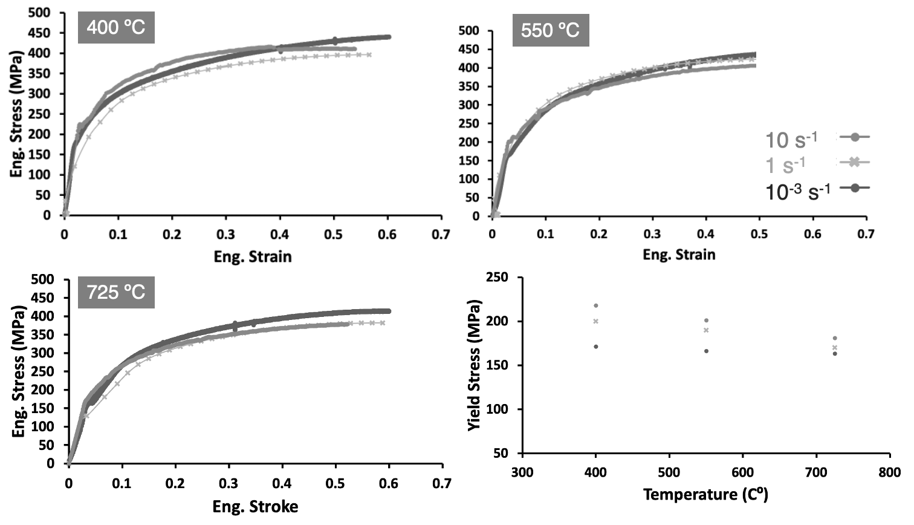
Figure 60.1: The above True stress-strain plots were gathered from wrought C-103 compression tests in the Gleeble at temperatures of 400, 550, 725 ºC and strain rates of 10, 1, and 10⁻³ s⁻¹, with the elastic region normalized and yield strengths taken at a .02% offset to create the flow stress plot. This same procedure was done for binaries containing 2 wt.% Ti, Zr, and Hf.

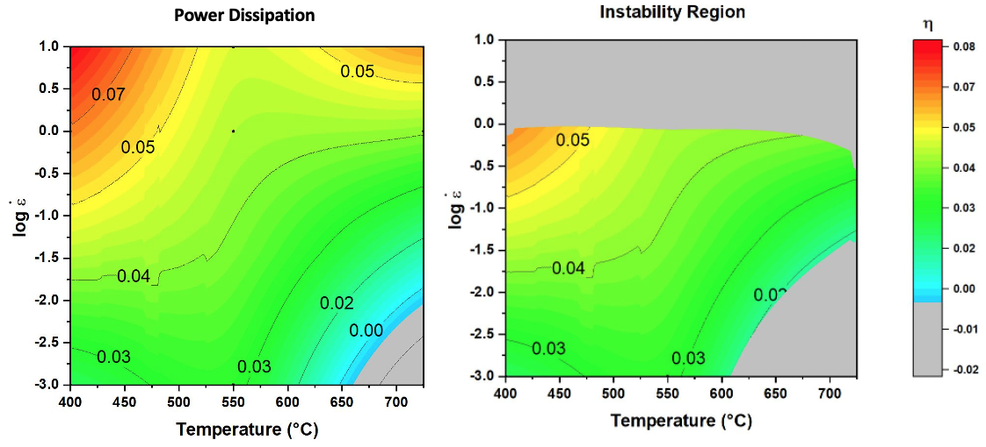
Figure 60.2: The above hot deformation processing map was created using the yield strength values [Figure 60.1] for wrought C-103. On the left power dissipation can be clearly seen, while the predicted instability region has been plotted in grey on the right.

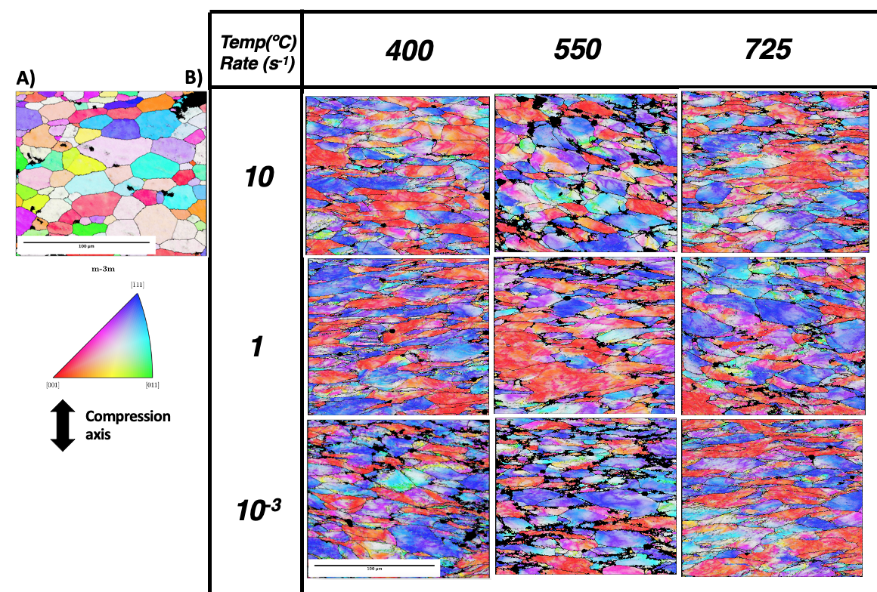
Figure 60.3: The above testing matrix shows EBSD images taken from the center of the wrought C-103 compression samples. In A) the wrought C-103 microstructure, while in B) the resulting microstructures for 60% reduction at the given temperature and strain rate.

Table 60.1: Simplified version of the initial heat treatment plan as well as alloy compositions. Temperatures selected for heat treatment #2 are dependent on the theoretical melting temperature of the given alloy. The planned percent deformation is 60%, however it is highly likely additional higher degrees of deformation will be attempted with this same heat treatment plan.
Alloy | Nb-Ti | Nb-Zr | Nb-Hf | Nb-V | Nb | Nb-Ta | Nb-Mo | Nb-W | Nb-Re | C-103
Initial binary Composition (wt.%) | 2 | 2 | 2 | 2 | 100 | 2 | 2 | 2 | 1 | NA
Heat treatment #1  (°C for 1 h) | 990 | 990 | 990 | 990 | 990 | 990 | 990 | 990 | 990 | 990
Heat treatment #2  (°C for 1 h) | 1050 | 1050 | 1075 | 1050 | 1100 | 1100 | 1100 | 1100 | 1100 | 1100

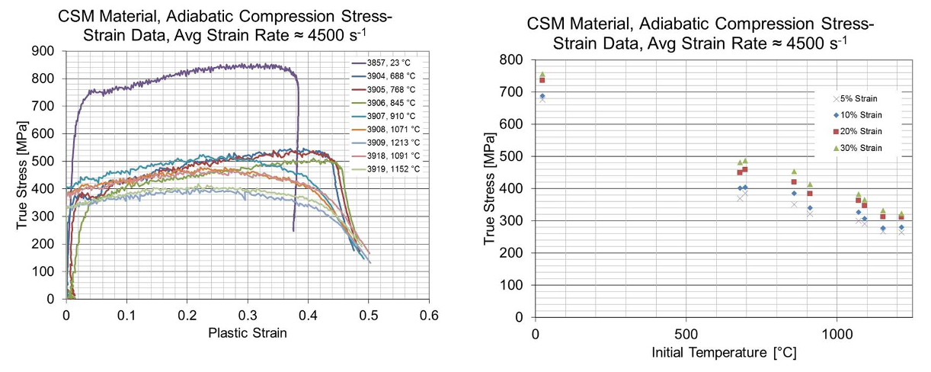
Figure 60.4: The above plots shows mechanical data gathered from C-103 Kolsky bar testing, at varying temperatures with a strain rate of 4500 s⁻¹ [60.14].

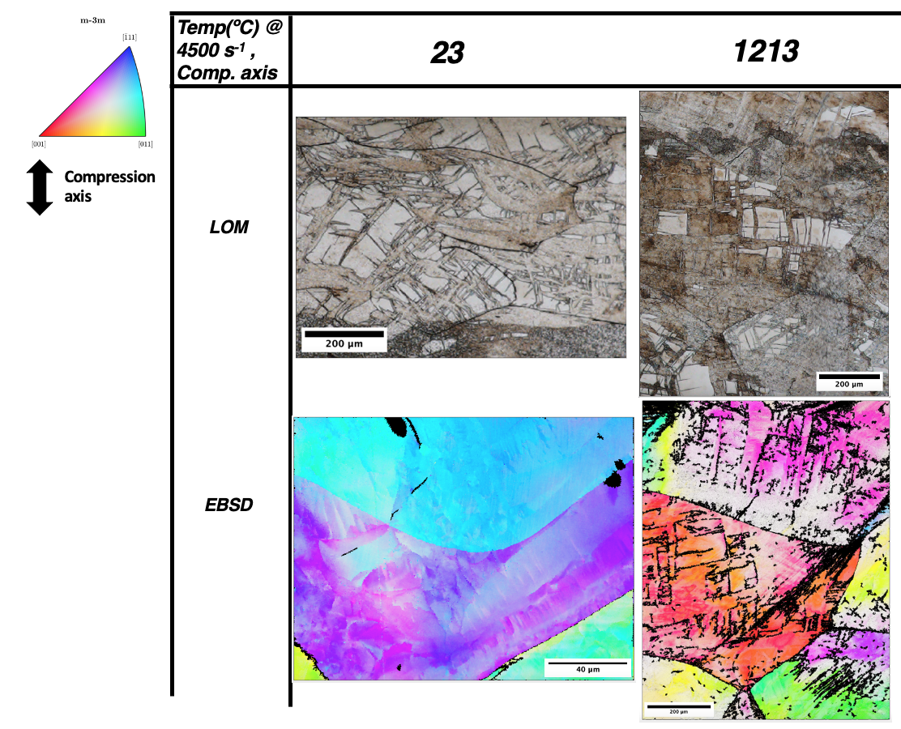
Figure 60.5: The above microstructures were taken from C-103 Kolsky bar testing, at room temperature and at 1213 ºC temperatures with a strain rate of 4500 s⁻¹ [60.14]. As one can see, there appear to be localized regions of the which accumulate high volume of strain and become unindexable. At higher temperatures it appears that these structures increase in density, leading to the belief that higher temperatures reduce lattice friction enough to allow for increased cross slip and higher dislocation density.

Table 60.2: Chemical analysis performed on 2wt.% binary alloys. Green denotes intended alloy content, yellow denotes unintended alloying content likely causing unfavorable deformation behavior to be observed during mechanical tests.